Name: MA3 due November 28, 2023
Uses math reasoning
Validation Situation
Evaluation criteria | Observable indicators corresponding to level
 | A | B | C | D | E
Analysis | 30 | 24 | 18 | 12 | 6
Application | 40 | 32 | 24 | 16 | 8
Justification | 20 | 16 | 12 | 8 | 4
Explanation | 10 | 8 | 6 | 4 | 2

The Rainbow Band is going on tour for 4 days.

The 40 people going on tour want to have snacks during the tour.

Each day, the organizers will provide each person with the following snacks:
- 1 apple.

- 2 juice boxes
- 1 granola bar.

The organizers have $275 to spend on snacks. Do they have enough money for the snacks they need for the 4 days of the tour?

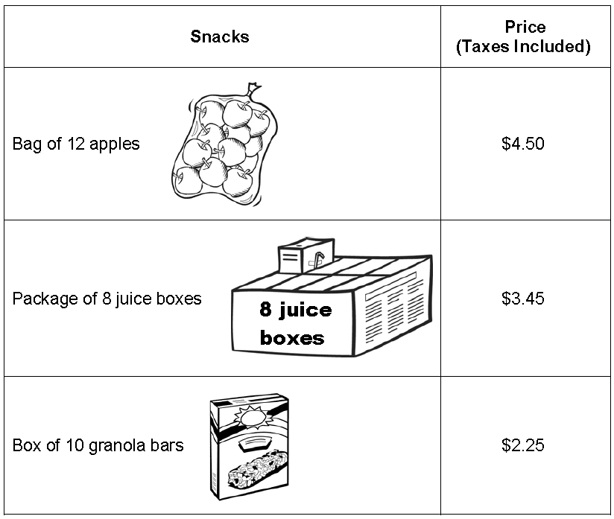

Do the organizers have enough money for the snacks they need for the 4 days of the tour?

Yes No

Use rigorous mathematical arguments to explain why.
________________________________________________________________________________________________________________________________________________________________________________________________________________________________________________________________________________________________________________________________________________________________________________________________________________

